Experiment No: 04

Experiment Name: Implementation of DDA (Digital Differential Analyzer)

Lab Task – 01: Using the DDA (Digital Differential Analyzer) line drawing algorithm, determine the intermediate points for a line drawn from (5, 7) to (10, 15). Also plot or list the pixel coordinates where the line will be displayed.

- Mathematical Calculation using DDA Algorithm:

- DDA Code (Without graphics):
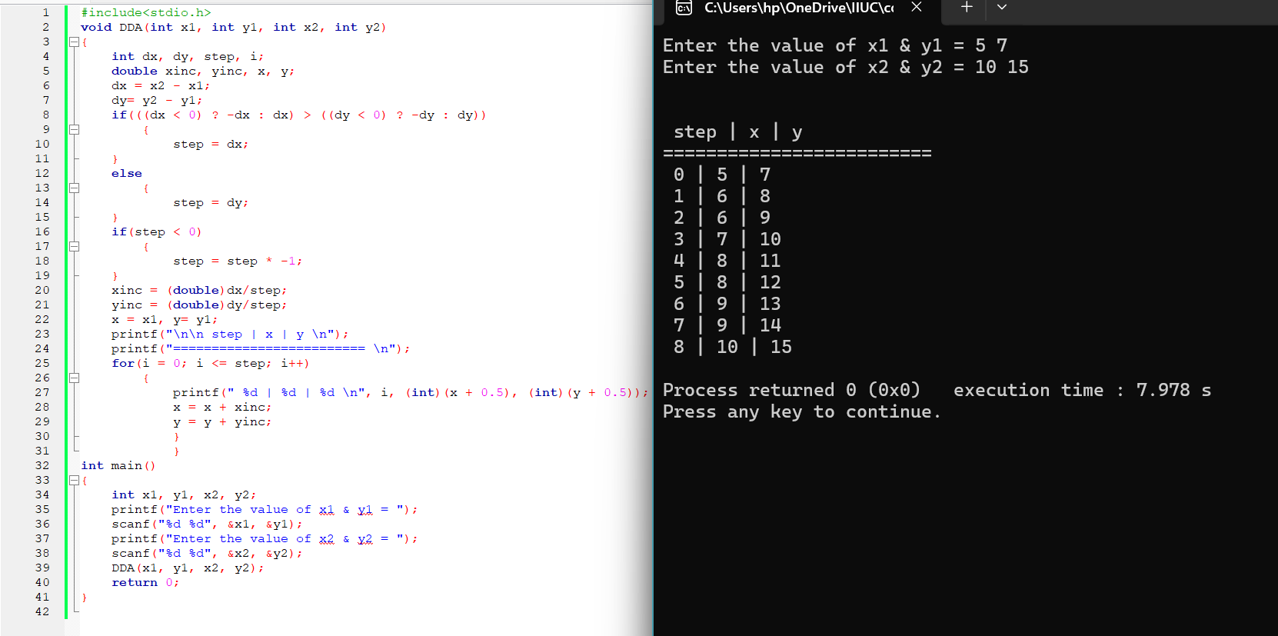
Fig – 01: Source Code and Output for DDA Code (Without graphics)

- DDA Code (With graphics):
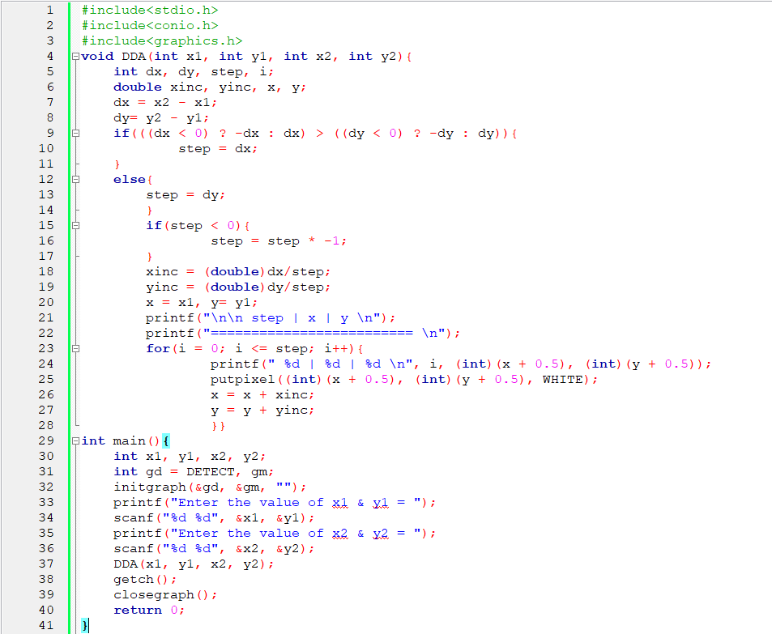
Fig – 02: Source Code for DDA Code (With graphics)
Output:
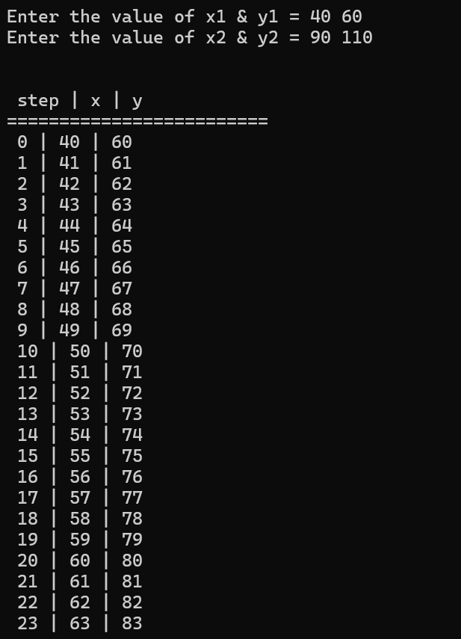
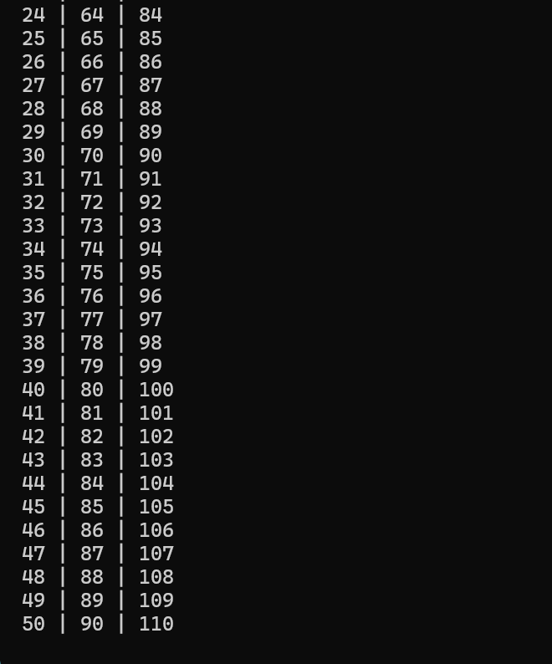
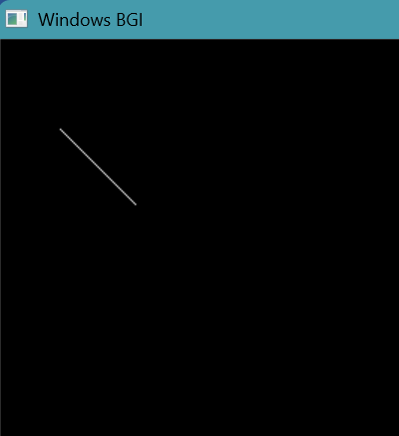
Fig – 03: Output for DDA Code (With graphics)

